UNIVERSITY OF SAN AGUSTIN
Information Technology Department
General Luna St. , Iloilo City

CpE 314 – Computer Engineering
2nd Semester SY 2024-2025

FINANALYZE: SMART ACCOUNT BOOK HELP YOU TRACK, ANALYZE YOUR COST EVERYDAY

A Software Project
Presented to
the Faculty of the Computer Engineering Program
University of San Agustin

In Partial Fulfillment
of the Requirements for the Course CPE 314
Software Design

by

WANG CHENLIN
JUANITAS JAN LOUIE
FRANCISCO NOLI VON

December 2024

TABLE OF CONTENTS

Title Page…………………………………………………………………………..i
Table of Contents….……………………………………………………………….ii
List of Figures……………………………………………………………………...ii
List of Tables …………………………………………………………………….. iv
List of Appendices ……………………………………………………………….. v
Acknowledgement ……………………………………………………………….. vi

SECTION PAGE
I INTRODUCTION …………………………………………………… 7
Purpose of Project Plan ……………………………………… 7
Project Scope and Objectives ……………………………….. 8
Statement of Scope ………………………………………….... 9
Major Functions ………………………………………………. 10
Performance Issues …………………………………………… 11
Management and Technical Constraints ……………………… 13
II SYSTEM’S DEVELOPMENT ………………………………………. 14

General Overview …………………………………………….. 14
System’s Methodologies ……………………………………… 19
Current System ……………………………………… ……… 20
Context Flow Diagram ………………………………………… 21
Data Flow Diagram (Level 1 to Level 2) …………………... 22- 24
Entity-Relationship Diagram …………………………………. 26

Proposed System ……………………………………………… 27
Context Flow Diagram for the Proposed System …………….. 27
Data Flow Diagram (Level 1 to Level 2) ………………….. 28-32
Entity-Relationship Diagram …………………………………. 33
Data Dictionary, Data Structures, DataElements………….. 34- 48
III SYSTEM’S IMPLEMENTATION …………………………………… 49
System’s Mechanics ………………………………………….. 49
System’s Decomposition Charts ……………………………… 50-51
Screen Layouts ……………………………………………….. 52-53
IV PROJECT MANAGEMENT ………………………………………… 54
Software Recommendation …………………………………... 55
Hardware Recommendation ………………………………….. 55
Peopleware Recommendation ………………………………... 56
System’s Budget ……………………………………………… 57
Cost Benefit Analysis ………………………………………… 58
Time Management ……………………………………………. 58
Bibliography ……………………………………………………………………... 58-59
Appendices ….…………………………………………………………………… 59-61

LIST OF FIGURES

FIGURE PAGE
- LVL 0 DFD/CFD ………...……………………………………….……21
- LVL 1 DFD ……………...………………………………….…………22-23
- LVL 2 DFD …………………………………………………………….23-24
- ERD ….…………………………………………………………………26
- Proposed CFD ………………………………………………………….27
- Proposed LVL 1 DFD …………………………… …………………...28-29
- Proposed LVL 2 DFD ………………………………………………… 29-32
- Proposed ERD ……………………………………… ………………33
- System's Decomposition Chart ... ………………………………………50-51
- Time Management ................ …………………………………………..58

LIST OF TABLES

TABLE PAGE
- Data Dictionary ………………………………………………………34-48
- Data Structure………………..…………………………………………34-48
- Data Elements……………………..…………………………………… 34-48
- System Budget…………..………………………………………………57
- Cost-Benefit Analysis..………………………………………………….58

LIST OF APPENDICES

APPENDIX PAGE

- Project Timeline ...………..………………………………………………. 60
- Survey Questionnaire and Results.………………………………………… 60
- Graphs from Survey Responses...………..………………………………... 61

ACKNOWLEDGEMENTS

We would like to express our sincere gratitude to Engr. Rowena D. Galzote for her continuous support, guidance, and valuable insights throughout the development of the Finanalyze project. Her mentorship has been instrumental in shaping our understanding of the technical and practical aspects of software development.

We also want to extend our heartfelt thanks to our professors and mentors who have generously shared their knowledge, expertise, and time, ensuring that we were equipped to tackle the challenges we faced during this project.

Special thanks go to the individuals and organizations that granted us permission and provided the resources we needed to develop and refine our ideas. We truly appreciate their contributions, which have played a vital role in bringing this project to life.
Finally, we acknowledge the teamwork and collaboration among our group members, Wang Chenlin, Juanitas Jan Louie, and Francisco Noli Von, whose dedication and hard work made this project a success.
We are immensely grateful for all the support we received along the way.

FINANALYZE – CHENLIN, JAN LOUIE, NOLI VON

SECTION 1

INTRODUCTION

In today's fast-paced world, managing personal finances efficiently is more important than ever. Many individuals struggle to keep track of their daily expenditures, leading to poor financial habits and unplanned spending. Traditional methods of tracking expenses, such as manually writing down purchases, are time-consuming and prone to error. With the increasing use of digital payment systems, there is a growing need for smarter, AI-driven tools to assist individuals in tracking and analyzing their consumption patterns.

Finanalyze is a financial management tool designed to simplify the process of monitoring and understanding personal spending. By integrating artificial intelligence (AI) with traditional methods of data entry, Finanalyze offers users a seamless way to record their purchases, analyze their expenses, and receive personalized financial insights. The platform also introduces social features that allow users to share their consumption data with friends, promoting financial transparency and better habits within a network.

With features like AI-powered receipt scanning, automatic categorization of expenses, and in-depth financial analysis, Finanalyze aims to empower users to take control of their finances and make informed decisions about their spending.

BACKGROUND OF THE STUDY

In today’s fast-paced world, managing daily expenses efficiently has become a growing concern for many individuals. With the rise of digital payments and online shopping, tracking expenses manually has become increasingly difficult and time-consuming. Many people struggle to keep up with their spending habits, leading to unnecessary financial strain and difficulty in budgeting. Financial management tools have been created to address these issues, but most are either overly complicated or do not provide real-time, actionable insights for users (Thomas & Green, 2022).

The target demographic, particularly young professionals and students, often finds traditional methods of budgeting either too complex or too tedious to maintain. These individuals require a more intuitive solution that fits into their busy lives, while also helping them make informed decisions regarding their financial health. There is a growing need for tools that not only track expenses but also offer personalized recommendations and analyses to help users improve their spending habits (Clark & Taylor, 2021).

Finanalyze: Smart Account Book seeks to fill this gap by offering an AI-powered solution that automatically tracks and categorizes daily purchases, provides personalized insights, and helps users visualize their financial habits. By simplifying the process of managing expenses and leveraging AI to reduce human error, the tool aims to empower users to make smarter financial decisions. This study examines the potential benefits of integrating AI into financial management tools and explores how Finanalyze can transform the way users approach personal budgeting and spending analysis.

The main objective of this project is to develop a user-friendly financial management system that offers accurate, real-time insights and makes budgeting a seamless part of daily life. By offering a system that minimizes manual effort while improving financial literacy, Finanalyze aims to contribute to healthier financial behaviors, especially among students and young professionals who may be new to managing their finances (Miller, 2020).

PURPOSE OF THE PLAN

The purpose of this plan is to create Finanalyze, a comprehensive tool aimed at enhancing users' financial management by providing an easy-to-use platform for tracking, analyzing, and sharing consumption data. This web-based system integrates AI to automate the categorization of expenses, analyze spending habits, and provide actionable insights that help users make smarter financial decisions (Miller & Clark, 2021). By offering features such as receipt scanning, automatic location tagging, and detailed financial analysis, Finanalyze will simplify the process of budgeting and financial tracking. The goal is to empower users, particularly those with busy lifestyles, to take control of their finances and reduce unnecessary spending. This study aims to assess how Finanalyze can assist in improving financial literacy, while fostering a more transparent and efficient approach to managing everyday expenses.

PURPOSE OF SCOPE AND OBJECTIVES

The purpose of the scope and objectives section is to outline the key aspects of the study, focusing on the development and impact of Finanalyze as a financial tracking and analysis tool.

a) General Purpose: The study aims to develop Finanalyze, a web-based platform that uses AI to automate financial tracking, categorize expenses, and provide users with insightful consumption data to improve their financial management.

b) Subject Matter and Topics Studied: The study focuses on areas such as AI-powered expense categorization, consumption data analysis, receipt scanning automation, financial literacy enhancement, and the integration of location-based tagging for purchase records. The analysis of spending patterns and the creation of a user-friendly interface are also central to this research.

c) Locale of the Study: The data for this study will be gathered from a range of users, primarily targeting individuals managing their finances, such as students, young professionals, and individuals seeking to track daily expenses. The research will focus on users in urban settings, where there is a higher demand for efficient financial management tools.

d) Period of the Study: The study will be conducted over a six-month period, starting from initial user research and prototype development to the testing phase and final release of the platform. During this time, the team will collect feedback, assess user behavior, and refine the tool based on findings.

e) Intention of the Team: The team's goal is to tackle the issue of inefficient financial management by creating Finanalyze as a comprehensive solution. The project aims to address the problem as a whole by providing a tool that integrates various financial management functions. Additionally, the team will work to solve the problem step by step through user-centered design, focusing on functionality, usability, and AI implementation.

MAJOR FUNCTION
Account Creation and User Management
This function allows users to create an account by providing basic details such as email, password, and optional personal information (e.g., contact numbers). Once the account is created, users can log in securely and manage their account settings. The system ensures that only authorized users can access their personal financial data, providing both a safe and personalized experience for managing their finances.
Automated Expense Tracking and Categorization
One of the key features of Finanalyze is its ability to automatically record and categorize expenses. Users can either manually input purchase details such as item name, price, and quantity or use the AI-powered receipt scanning feature to extract and categorize these details automatically. The AI classifies purchases into predefined categories (e.g., Food, Transportation, Entertainment), helping users understand their spending patterns with minimal manual effort.
Spending Analytics and Insights
This function provides users with detailed analytics of their spending behavior, offering insights through charts and graphs. The system tracks and displays statistics on consumption in various categories, allowing users to compare their expenses over different time periods (e.g., daily, weekly, monthly). By analyzing these trends, users can identify areas where they may need to adjust their spending and develop better financial habits.
Social Sharing and Community Insights
In addition to personal tracking, Finanalyze allows users to share their financial records with friends and family, creating a sense of community. Users can make certain records public or private, fostering a supportive environment where individuals can learn from each other’s spending habits. Additionally, users can ask questions to an AI chatbot about their financial situation, which is based on their own consumption data or shared experiences with their network.

PERFORMANCE ISSUE
Despite the features and capabilities of Finanalyze, there are several performance issues that need addressing to improve user experience and functionality.

Manual Data Entry
Although users can manually input transaction details, this process is often slow and prone to errors. Users may forget to log transactions or enter incorrect details, leading to incomplete or inaccurate financial records. This affects the effectiveness of the system in tracking and categorizing expenses properly.

Receipt Scanning Accuracy
While the AI-powered receipt scanning function is designed to automate data input, it can struggle with accurately interpreting receipt data. Misread or incomplete data often requires manual corrections, which defeats the purpose of automating the process and can lead to user frustration.

Category Classification Issues
The AI system sometimes fails to accurately classify expenses into the predefined categories (such as "Food," "Clothing," or "Electronics"). Misclassification leads to incorrect data analysis, making it harder for users to track their spending in the correct category. This affects the utility of the system for providing useful insights and recommendations based on spending patterns.

Slow System Performance
The response times of the system, especially during data processing and report generation, can be sluggish. When users input large datasets or request analytics over a long period, the system may take too long to deliver results. This delay detracts from the overall user experience, particularly for those seeking real-time feedback on their financial habits.

Limited Data Visualization
While the system offers charts and reports, the visual representations of data are sometimes insufficient or overly simplistic. Users may find it challenging to derive detailed insights from the graphs and charts provided. Additionally, the system may not offer advanced filtering or customization options to suit different user preferences, reducing its effectiveness in analyzing complex financial data.

MANAGEMENT AND TECHNICAL CONTRAINTS

The project faces several management constraints that must be considered throughout its development. First, there are budget limitations, which require careful planning and prioritization of features to stay within the financial resources allocated. The project also has a fixed timeline, and all deliverables must be completed by the specified deadline, necessitating efficient scheduling and task management. Additionally, personnel availability is another constraint, as team members have limited time to dedicate to the project. Balancing workloads and ensuring the right people are available for critical tasks is essential. The project must also comply with organizational policies, including security protocols, data protection regulations, and software usage guidelines, with any deviations potentially causing delays or complications. Finally, the project must meet stakeholder expectations, requiring regular communication to ensure the system aligns with the needs and requirements of the users, clients, and administrators.
On the technical side, the system must ensure compatibility with the existing hardware and software infrastructure, which may limit the choice of technologies and features. Additionally, the system's data storage capacity must be sufficient to handle a large volume of transactions without impacting performance, requiring careful database design and capacity planning. Security and privacy are paramount, meaning the system must implement robust security measures, including encryption, secure authentication, and compliance with privacy laws like GDPR. This could restrict some design choices or increase development complexity. The system must also integrate with external systems such as payment processors or user authentication services, which may limit the flexibility of certain functionalities based on compatibility. Finally, the system must be designed for performance and scalability, ensuring it can handle increasing users and transactions over time without degradation in performance, demanding thoughtful decisions regarding optimization, load balancing, and database indexing.

SECTION II

SYSTEM’S DEVELOPMENT

GENERAL OVERVIEW
Finanalyze is a sophisticated consumption tracking and analysis tool designed to provide users with an intelligent and effortless way to manage their finances. The platform integrates advanced Artificial Intelligence (AI) to automate the tracking, categorization, and analysis of daily purchases, helping users gain deeper insights into their spending habits. At its core, Finanalyze offers an account system where users can securely create profiles with email and password, optionally including basic information such as contact numbers and personal details. Once registered, users can begin tracking their daily purchases by either manually entering transaction details or allowing the AI to process receipt images to automatically extract item names, prices, quantities, and brands.

The AI system classifies transactions into predefined categories such as "Food," "Clothing," and "Transportation" (based on predefined category values like "Food," "Electronics," and more), offering an organized and easy-to-navigate experience. The platform records additional transaction details such as the purchase location, time, and date, ensuring that users maintain a comprehensive and up-to-date record of their spending.

The Analysis and Training feature helps users gain deeper insights into their financial behavior by offering consumption statistics displayed in charts and diagrams. Users can review their spending patterns across different time frames (daily, weekly, monthly, and yearly), helping them identify areas where they can improve their financial habits.

Finanalyze also includes a Sharing feature that allows users to connect with friends, compare consumption data, and share specific records with others. Users have control over the visibility of their records, as they can choose to make certain entries public or keep them private.

Historical Background
The development of Finanalyze emerged from a growing awareness of the challenges people face in managing their finances in an increasingly complex world. Over the years, personal finance management has evolved from paper-based ledgers and manual calculations to digital spreadsheets and, more recently, fully automated applications. However, despite the advancement in technology, many existing tools have been either too complex for everyday users or too simplistic to provide meaningful insights into spending behavior. Historically, personal finance tools have been designed with a one-size-fits-all approach, where users are required to manually input their expenses, categorize them, and track their budgets. While these tools offered some degree of help, they still left much to be desired, especially in terms of automation and personalization. As AI and machine learning technologies advanced, the potential to automate and personalize financial management grew. The concept of Finanalyze was conceived to bridge the gap between these traditional tools and modern, AI-powered applications. The idea was born out of a realization that many people whether young professionals, students, or working adults struggled to stay on top of their finances due to a lack of time, motivation, or financial knowledge. While budgeting apps existed, they often required detailed inputs and analysis from users, which many found tedious and time-consuming. The introduction of AI into the Finanalyze platform marked a major step forward. By leveraging the power of artificial intelligence, the system could automatically record transactions, categorize them, and provide real-time insights into spending patterns. This innovation reduced the barriers for individuals who were either unfamiliar with budgeting tools or found the process too cumbersome. Over time, Finanalyze also evolved to cater to a wider audience, moving beyond just traditional consumers to include individuals interested in financial analysis, peer comparisons, and sharing financial data. The platform integrated advanced features such as AI-powered receipt scanning, automatic categorization of purchases, and detailed financial reports, ultimately transforming how people interact with their finances.

Geographical Conditions
The Finanalyze platform was developed to serve users across a broad geographical range, recognizing that financial challenges and behaviors vary depending on the region, local economy, and cultural norms. Users are spread across urban and rural areas, both locally and globally, and these geographical conditions influence how Finanalyze operates and the features it prioritizes.

In diverse economic environments, users from different regions experience varying levels of economic stability, income, and consumer behavior. Developed areas may have more disposable income, while users in developing regions focus on budgeting and cost-saving. To address this, Finanalyze offers features like automatic currency conversion and budgeting options tailored to different financial goals. The platform also accounts for urban versus rural spending habits. Urban users may spend more on entertainment and dining out, while rural users focus on essential expenses like food and utilities. Finanalyze offers personalized financial insights based on location, providing smart spending recommendations. Access to financial services is another consideration, as some regions have limited banking options. In such cases, Finanalyze allows manual expense input and receipt scanning, ensuring that users in areas with less digital infrastructure can still benefit from the platform. Cultural influences on spending, such as seasonal festivals or holidays, are also factored into the platform's features. Finanalyze tracks these fluctuations, helping users manage finances throughout the year. Finally, the platform supports multiple languages and adapts to regional tax laws, payment systems, and privacy regulations, ensuring a seamless user experience for a global audience.

Problem
The primary problem that Finanalyze seeks to address is the difficulty many individuals face in managing and tracking their daily spending habits effectively. With the increasing complexity of financial decisions, especially in diverse economic environments, users often struggle to maintain control over their finances and make informed decisions. Current financial management tools may not be easily accessible, adaptable, or intuitive, especially for users from regions with limited banking infrastructure or varying cultural norms.

Additionally, many users lack the necessary tools to track expenses accurately, categorize purchases, or identify patterns in their spending behavior. Without detailed insights, it can be challenging to implement effective budgeting, save money, or reduce unnecessary expenses. This problem is further compounded by the inability of many platforms to offer personalized recommendations based on geographical and economic factors, leading to a disconnect between user needs and available financial solutions.

Moreover, with increasing reliance on digital payments, many users face issues with manual entry and categorization of expenses, particularly in regions where banking services are limited. Finanalyze aims to solve these problems by integrating AI-powered features that automate expense tracking, offer relevant insights based on the user's economic context, and provide a seamless user experience tailored to different geographical conditions and financial needs.

SYSTEM’S METHODOLOGIES
The researcher’s analysis of the Finanalyze system involves a thorough evaluation of the current financial management tools and the factors that have driven the need for a new approach. The analysis utilizes various methodologies, including qualitative research through user interviews and focus groups, where users from different demographics provided feedback on the limitations of existing systems, such as the burden of manual data entry and the lack of AI-powered automation. A competitive analysis of popular tools like Mint, YNAB, and Expensify revealed significant gaps in their ability to adapt to regional differences and offer personalized insights. Quantitative research, including usage data analysis, identified inefficiencies in current systems, such as frequent manual inputs and categorization errors. Technological assessments confirmed that AI and OCR technology could be harnessed to automate processes like receipt scanning and expense categorization, enhancing user experience. Usability testing of both current and proposed systems showed that users preferred automation and AI capabilities but wanted more regional customization. Several key factors led to the need for a new system, including the limitations of manual data entry, lack of personalized advice, and the failure of existing platforms to accommodate diverse geographical and economic conditions. Many users, especially in developing regions, face challenges with limited access to banking and digital payment services, which current systems do not adequately address. Moreover, existing systems do not provide real-time insights or offer region-specific recommendations. The proposed system, Finanalyze, aims to fill these gaps by offering automation, AI-driven personalized financial insights, and regional customization to cater to users across diverse economic environments. By integrating features like multiple language support, currency conversion, and manual input options, Finanalyze is designed to be accessible to users with varying levels of financial service access. In conclusion, the researcher’s analysis highlights the need for a more adaptable, automated, and user-friendly financial management system, and Finanalyze aims to address these challenges with its innovative features.

CURRENT SYSTEM

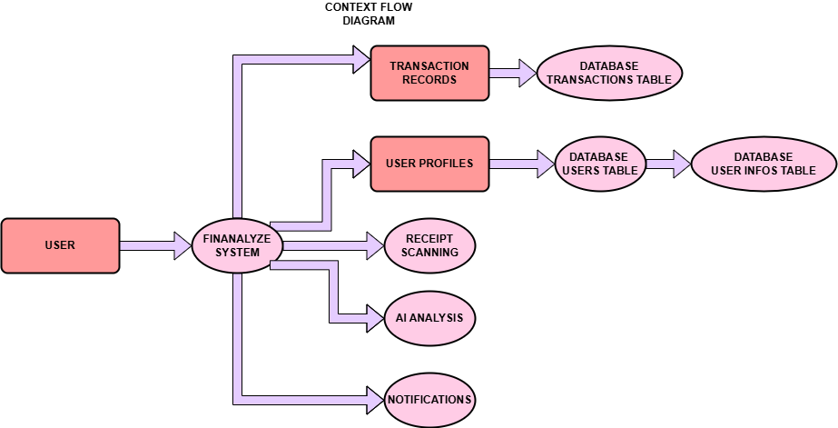

In the context flow diagram (CFD), the User (represented as an oval) is the external entity that interacts with the Finanalyze System (depicted as a rectangle, representing a process). The User provides input to the system in the form of transaction data and personal information. The Finanalyze System is responsible for managing and processing this data, specifically handling Transaction Records and User Profiles. Transaction data is stored in the Transactions Table in the database, while user-related information is stored in the Users Table, which further links to the User Infos Table that holds detailed personal data.
The system also includes processes for Receipt Scanning, where users upload receipts for data extraction, and AI Analysis, which leverages artificial intelligence to categorize and analyze spending patterns. Additionally, the Finanalyze System sends Notifications to the User, alerting them of important events such as budget alerts or transaction updates. These processes are essential for ensuring the system’s functionality, providing valuable insights to the User and keeping them informed about their financial activity.

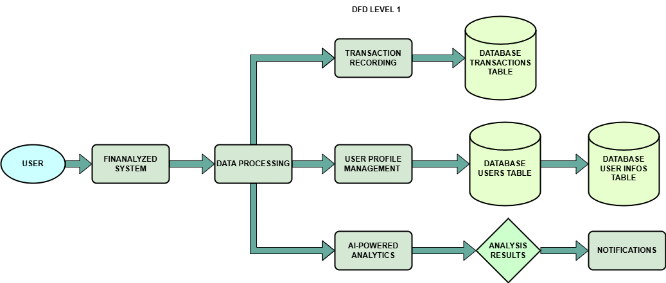

The diagram illustrates the overall workflow of the Finanalyze System and its components. The User, represented as an external entity, interacts with the Finanalyze System. The system serves as the central process, which branches into a key subprocess: Data Processing. Within the data processing stage, there are two major functionalities: Transaction Recording and User Profile Management. The Transaction Recording module is responsible for capturing and storing financial transaction details in the Database: Transactions Table. Simultaneously, the User Profile Management module handles user-related information, updating and maintaining records in the Database: Users Table, which in turn is linked to the Database: User Infos Table for storing additional user-specific details like personal information and preferences. Beyond data recording and management, the system employs AI-Powered Analytics to process the stored data and generate Analysis Results, such as insights into spending patterns or expense categorization. These results are then utilized to produce Notifications, ensuring that the user is informed about their financial activity, trends, or recommendations. This structure highlights the seamless integration of data handling, AI-driven insights, and user interaction, demonstrating how the Finanalyze System provides a comprehensive solution for financial tracking and analysis.

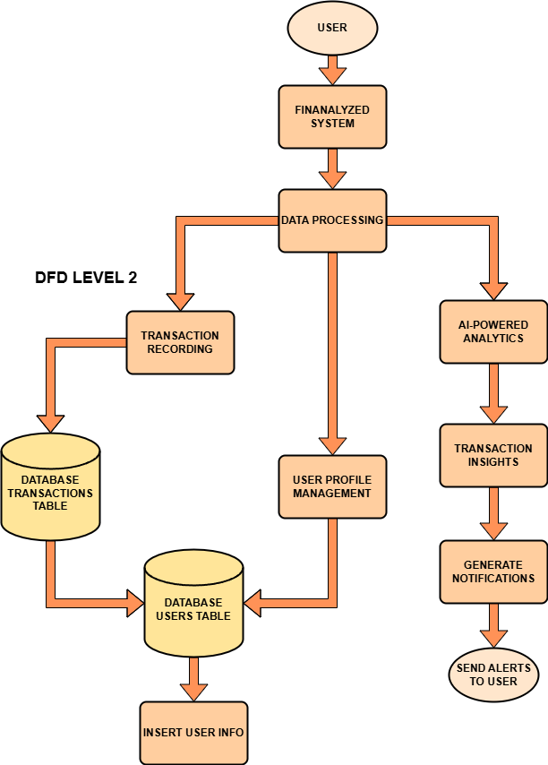

The diagram illustrates the flow of data and processes in the Finanalyze System, starting with the User as the initiating entity. The user interacts with the system, triggering operations within the main process represented by the Finanalyze System. The system's core functionality is divided into several subprocesses. First, Data Processing acts as the central hub for managing various operations. Within this, Transaction Recording captures transaction details entered by the user and stores them in the Transactions Table database. The operation to Insert Transaction Record ensures that each transaction is saved and accessible for future analysis. Simultaneously, User Profile Management handles the management of user-related data, interacting with the Users Table database. This process involves operations like Insert User Info, which updates or adds new information about users. The system also includes an advanced feature, AI-Powered Analytics, which analyzes stored transaction data to generate valuable Transaction Insights. These insights are processed further to Generate Notifications, which are tailored alerts or updates for the user. Finally, the system completes the loop by Sending Alerts to the User, ensuring the user receives actionable insights or reminders based on their data. This structured approach highlights the system's robust data handling, AI-driven analysis, and user-centric notification mechanism, ensuring efficient and personalized financial tracking and management.

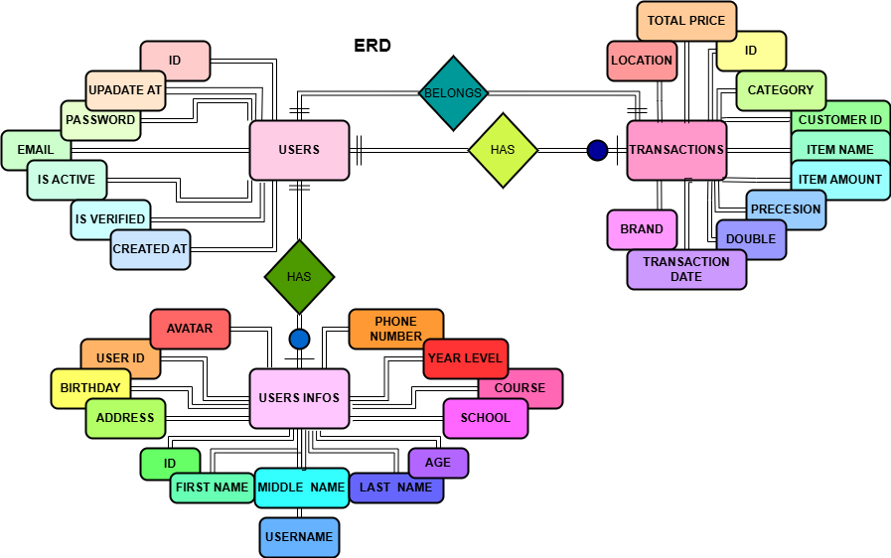

This Entity-Relationship Diagram (ERD) outlines the database structure for a system that manages users, their transaction records, and detailed profile information. The system consists of three main entities: USERS, TRANSACTIONS, and USER_INFOS. The USERS entity represents registered accounts in the system, storing key attributes like a unique user ID, email, password, account status, verification status, and timestamps for account creation and updates. The TRANSACTIONS entity records all user purchases, with attributes for transaction ID, consumer ID linking it to the user, item details, purchase location, brand, category, and transaction date. The USER_INFOS entity captures additional profile details, such as a user’s name, age, gender, birthday, address, contact information, and academic data if applicable.

The relationships between these entities are crucial for ensuring data organization and consistency. The USERS table has a one-to-many relationship with TRANSACTIONS, meaning a single user can have multiple transaction records. Each transaction, however, belongs to one specific user, creating a clear link between the buyer and their purchases. The USERS table also has a one-to-one relationship with USER_INFOS, indicating that each user can have a detailed profile, although this is optional. This profile information is stored separately to maintain modularity and allow for additional details to be added as needed. This structure ensures that user accounts, transactions, and profile data are interconnected while maintaining clarity and scalability. The relationships defined, such as "has" and "belongs to," provide a logical flow, enabling seamless tracking of user activities and profiles within the system.

PROPOSED SYSTEM

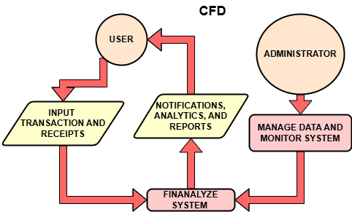
In this context flow diagram, the User and Administrator are external entities interacting with the Finanalyze System. The User provides input in the form of Transactions and Receipts, which are received by the Finanalyze System. In return, the system sends Notifications, Analytics, and Reports back to the User, offering feedback and insights on their data. On the other hand, the Administrator interacts with the system in a managerial capacity, performing actions such as Managing Data and Monitoring the System. This process highlights how the Administrator oversees the operation of the Finanalyze System, ensuring that everything functions properly. Essentially, the diagram illustrates the flow of information between users, administrators, and the central system, emphasizing the key inputs and outputs within the system.

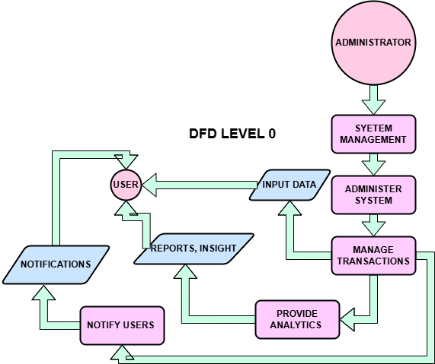

In the flowchart you’ve outlined, there are interactions between the User, Administrator, and the System. The User starts by inputting data, which flows into the process Manage Transactions. This process is where the system handles the transactions entered by the User. After managing the transactions, the system proceeds to Provide Analytics, which generates insights based on the input data. These analytics are then sent back to the User as Reports and Insights. Additionally, the Manage Transactions process is responsible for Notify Users, sending notifications to the User as updates or alerts about their transactions or the system’s status. On the other hand, the Administrator interacts with the system by System Management, which involves overseeing and controlling the system’s operation. The Administrator’s management flows into the process Administer System, which ensures the system functions smoothly and correctly. This management action influences the Manage Transactions process, ensuring it operates under the Administrator’s supervision. The diagram illustrates the flow of data and interactions, making it clear how different roles (User and Administrator) interact with the system and how data moves through various processes.

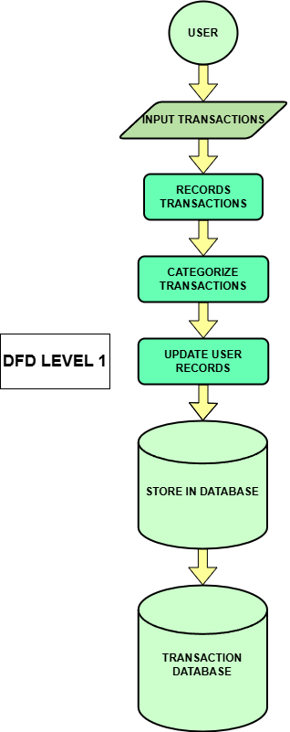

In this flowchart, the process begins with the User who inputs transactions into the system. This is represented by the arrow from User to Record Transactions, where the system captures and logs each transaction. The Record Transactions step is the first point where the system processes the inputted data, ensuring it is properly recorded.

Next, the recorded transactions are passed to the Categorize Transactions step. Here, the system organizes the transactions into categories, perhaps based on type (e.g., purchase, refund) or other relevant criteria. This step helps in making sense of the data for further actions.

Once the transactions are categorized, they move to the Update User Records step, where the system updates the user’s account or profile with the categorized transaction details. This could involve adjusting balances, recording spending habits, or reflecting new purchases in the user's transaction history.

Finally, the updated user records are passed to the Transaction Database, where they are stored for future retrieval. This step ensures that the transaction data is saved in a persistent storage system, allowing it to be accessed, analyzed, or referenced as needed.

The flowchart visually represents the sequence of steps that the transactions go through, from the initial input by the user to the final storage in the database. Each step in the process is represented by a specific shape, such as rectangles for processes and a cylinder for the database, providing a clear view of the data flow and system operations.

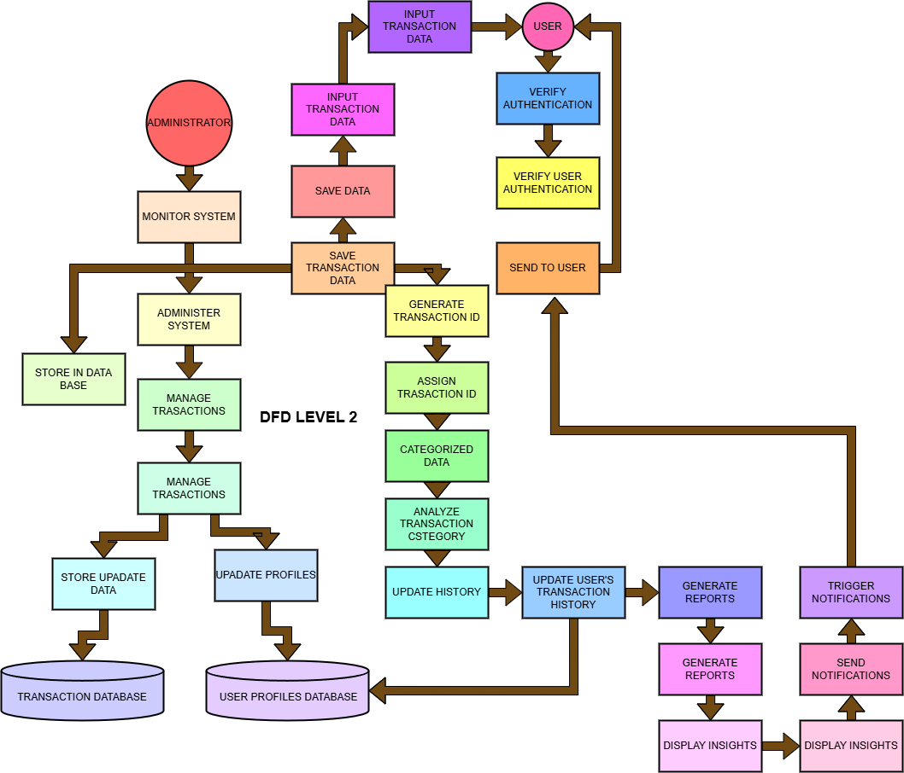
The diagram represents a Level 2 Data Flow Diagram (DFD) for the Finanalyze System, which manages user transactions, categorizes them, provides analytics, and sends notifications, with an administrative process for managing the system.
The User interacts with the system by inputting transaction data and verifying their authentication. Once the data is entered, it triggers the process 1.1: Input Transaction Data, which saves the transaction in the Transaction Database and generates a Transaction ID through 2.1: Save Transaction Data and 2.2: Assign Transaction ID. The system then categorizes the transactions by analyzing their types (such as food, entertainment, etc.) through 3.1: Analyze Transaction Category and updates the user’s transaction history with 3.2: Update User’s Transaction History. The updated data is then stored in the User Profiles Database. After updating the transaction history, the system generates reports (4.1: Generate Reports) and displays insights (4.2: Display Insights) to the user. If necessary, the system sends notifications to the user through 5.1: Trigger Notifications, which are delivered back to the user. The Administrator has a role in monitoring the system. They interact with Administer System, which allows them to manage transactions and update user profiles. The administrator is able to update data in the Transaction Database and modify user profiles in the User Profiles Database. This diagram outlines the flow of data between external entities (User, Administrator) and processes (input, categorization, analytics, notification), along with the data stores (Transaction Database, User Profiles Database) in a detailed and structured way.

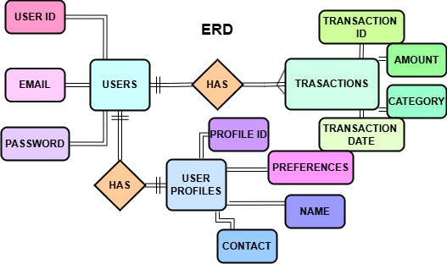

The Entity-Relationship Diagram (ERD) outlines the structure of a system that manages users, transactions, and user profiles. The USERS entity stores basic user information, such as a unique userID, email, and password. Each user can have multiple TRANSACTIONS, with each transaction containing details like a unique transactionID, amount, category, and transactionDate. The relationship between USERS and TRANSACTIONS is one-to-many, meaning a single user can have many transactions, but each transaction is linked to only one user. Additionally, the USER_PROFILES entity holds extra information about users, including their profileID, name, contact, and preferences. The relationship between USERS and USER_PROFILES is one-to-one, indicating that each user has one unique profile, and each profile is associated with only one user. This diagram demonstrates how the system organizes and links data, ensuring users' transactions and profiles are managed efficiently while maintaining clear connections between different entities.

Table

Data Dictionary:

Name | Description | Contents | Volume | Access
id | A unique identifier for each user. Used as the primary key in the users table. | UUID | One entry per user in the system. | System administrators, developers
is_verified | Indicates whether the user’s email has been verified. | Boolean (true/false) | Matches the total number of user accounts. | System administrators
created_at | Timestamp indicating when the user account was created. | Date and time | Matches the total number of user accounts. | System administrators, developers
updated_at | Timestamp indicating when the user account was last updated. | Date and time | Matches the total number of user accounts. | System administrators, developers
email | The email address associated with the user account. Used for login and communication. | String | Matches the total number of user accounts. | System administrators
password | The hashed password used for authenticating the user. | String (hashed value) | Matches the total number of user accounts. | System administrators (limited)

Data Structures:

Name | Description | Contents | Where Used
id | A unique identifier for a user. | UUID | Primary key in users table.
is_verified | Boolean value indicating email verification. | true or false | Email verification workflows.
email | Email address of the user. | String | User login, communication.
password | The user’s hashed password for authentication. | String (hashed) | Login and authentication.

Data Elements:

id
• Definition: A unique identifier for each user.
• Alias: None.
• Type: UUID.
• Length: 36 characters.
• Validation Rule: Must be unique; auto-generated.
• Source: System-generated.

is_verified
• Definition: Indicates whether the user’s email is verified.
• Alias: None.
• Type: Boolean.
• Length: N/A.
• Validation Rule: Default value is false.
• Source: Email verification process.

created_at
• Definition: The date and time when the user account was created.
• Alias: None.
• Type: Timestamp.
• Length: N/A.
• Validation Rule: Auto-filled when the account is created.
• Source: System-generated.

updated_at
• Definition: The date and time when the user account was last updated.
• Alias: None.
• Type: Timestamp.
• Length: N/A.
• Validation Rule: Auto-updated on any modification.
• Source: System-generated.

email
• Definition: The email address of the user.
• Alias: None.
• Type: String.
• Length: Up to 255 characters.
• Validation Rule: Must be unique and match email format.
• Source: User-provided.

password
• Definition: The hashed password for user authentication.
• Alias: None.
• Type: String.
• Length: Variable depending on hash algorithm.
• Validation Rule: Stored as a hashed value.
• Source: User-provided and system-hashed.

Table <user_infos>

Data Dictionary:

Name | Description | Contents | Volume | Access
id | A unique identifier for each entry in the table. | UUID | One entry per individual record. | System administrators, developers
user_id | A reference to the user who owns the record. | UUID | Matches the total number of records. | System administrators
age | The age of the user. | Integer | Matches the total number of user profiles. | System administrators
birthday | The date of birth of the user. | Date | Matches the total number of user profiles. | System administrators
middle_name | The middle name of the user. | String (Text) | Matches the total number of user profiles. | System administrators
last_name | The last name of the user. | String (Text) | Matches the total number of user profiles. | System administrators
avatar | The path or URL to the user’s profile picture. | String (Text) | Matches the total number of user profiles. | System administrators
year_lvl | The year level of the user (e.g., student year). | String (Text) | Matches the total number of records. | System administrators
gender | The gender of the user. | String (Text) | Matches the total number of records. | System administrators
school | The school or institution the user is associated with. | String (Text) | Matches the total number of records. | System administrators
address | The user’s residential address. | String (Text) | Matches the total number of records. | System administrators
phone_number | The user’s contact phone number. | String (Text) | Matches the total number of records. | System administrators
course | The course or field of study the user is enrolled in. | String (Text) | Matches the total number of records. | System administrators
username | The unique username associated with the user. | String (Text) | Matches the total number of records. | System administrators
first_name | The first name of the user. | String (Text) | Matches the total number of records. | System administrators

Data Structures:

Name | Description | Contents | Where Used
id | A unique identifier for a record. | UUID | Primary key in the table.
user_id | A reference to the users table. | UUID | Relational queries.
birthday | Represents the user’s date of birth. | Date | Profile-related queries.
phone_number | Contact number for the user. | String | Contact-related reports.

Data Elements

id
• Definition: A unique identifier for each entry in the table.
• Alias: None.
• Type: UUID.
• Length: 36 characters.
• Validation Rule: Must be unique; auto-generated.
• Source: System-generated.

user_id
• Definition: A foreign key that links to the users table.
• Alias: None.
• Type: UUID.
• Length: 36 characters.
• Validation Rule: Must reference a valid entry in the users table.
• Source: System-generated.

age
• Definition: The user’s age in years.
• Alias: None.
• Type: Small integer.
• Length: 2 bytes.
• Validation Rule: Must be a positive integer.
• Source: User-provided or derived from birthday.

birthday
• Definition: The user’s date of birth.
• Alias: None.
• Type: Date.
• Length: N/A.
• Validation Rule: Must be a valid date in the past.
• Source: User-provided.

avatar
• Definition: A string pointing to the profile image location.
• Alias: None.
• Type: String.
• Length: Variable.
• Validation Rule: Must be a valid file path or URL.
• Source: User-uploaded.

phone_number
• Definition: The contact number of the user.
• Alias: None.
• Type: String.
• Length: Variable.
• Validation Rule: Must match phone number format.
• Source: User-provided.

Table <transactions>

Data Dictionary:

Name | Description | Contents | Volume | Access
transaction_date | The date when the transaction occurred. | Date | Matches the total number of transactions. | System administrators
consumer_id | A unique identifier for the consumer who made the transaction. | UUID | Matches the total number of consumers. | System administrators
price_per_unit | The price for a single unit of the purchased item. | Double precision | Matches the total number of transactions. | System administrators
total_price | The total price paid for the transaction (price per unit × item amount). | Double precision | Matches the total number of transactions. | System administrators
img | The reference or URL to the item’s image. | UUID | Matches the total number of items. | System administrators
id | A unique identifier for the transaction. | UUID | Matches the total number of transactions. | System administrators
item_amount | The quantity of items purchased in the transaction. | Small integer | Matches the total number of transactions. | System administrators
item_name | The name or title of the item purchased. | String (Text) | Matches the total number of items. | System administrators
location | The place where the transaction took place or the consumer’s address. | String (Text) | Matches the total number of transactions. | System administrators
brand | The brand or manufacturer of the purchased item. | String (Text) | Matches the total number of items. | System administrators
category | The category or classification of the purchased item. | String (Text) | Matches the total number of items. | System administrators

Data Structures:

Name | Description | Contents | Where Used
transaction_date | Represents the date of the transaction. | Date | Report generation, summaries.
consumer_id | Links to the unique identifier of the consumer. | UUID | Relational queries.
price_per_unit | The cost of one unit of the item. | Double precision | Report calculations.
total_price | The total cost for all items in the transaction. | Double precision | Summaries, financial reports.
img | Reference to an image representing the item. | UUID | Visual reports.

Data Elements:

transaction_date
• Definition: The date when the transaction took place.
• Alias: None.
• Type: Date.
• Length: N/A.
• Validation Rule: Must be a valid date, not in the future.
• Source: User-provided or system-generated.

consumer_id
• Definition: The unique identifier of the consumer.
• Alias: None.
• Type: UUID.
• Length: 36 characters.
• Validation Rule: Must reference a valid consumer entry in the consumers table.
• Source: System-generated.

price_per_unit
• Definition: The price per individual unit of the item purchased.
• Alias: None.
• Type: Double precision.
• Length: N/A.
• Validation Rule: Must be a non-negative decimal.
• Source: User-provided.

total_price
• Definition: The total cost of the transaction (calculated as price_per_unit × item_amount).
• Alias: None.
• Type: Double precision.
• Length: N/A.
• Validation Rule: Must be a non-negative decimal.
• Source: Derived from price_per_unit and item_amount.

img
• Definition: A reference or URL to the item’s image.
• Alias: None.
• Type: UUID.
• Length: 36 characters.
• Validation Rule: Must reference a valid image entry or URL.
• Source: User-uploaded.

Table <ai_chat>

Data Dictionary:

Name | Description | Contents | Volume | Access
id | Unique identifier for the chat session. | UUID | Matches the total number of chat entries. | System administrators
user_id | Unique identifier of the user associated with the chat. | UUID | Matches the total number of users. | System administrators
contents | An array of individual messages within the chat. | Array | Matches the total number of chat messages. | System administrators
full_contents | The complete conversation content in array format, including metadata. | Array | Matches the total number of chats. | System administrators
created_at | Timestamp indicating when the chat entry was created. | Text | Matches the total number of chat entries. | System administrators
updated_at | Timestamp indicating when the chat entry was last updated. | Text | Matches the total number of chat entries. | System administrators
title | Title or topic of the chat session. | Text | Matches the total number of chat entries. | System administrators
pre_text | Optional preliminary text or instruction provided before the chat begins. | Text | Matches the entries with pre-chat instructions. | System administrators

Data Structures

Name | Description | Contents | Where Used
id | Represents the unique identifier for the chat. | UUID | Reference in queries.
contents | Contains individual messages as an array. | Array | For reconstructing conversations.
full_contents | Stores the entire chat history in an array. | Array | For analysis or review.
created_at | Indicates when the chat session was created. | Text | Timestamps for logs or reports.

Data Elements

id
• Definition: A unique identifier for each chat session.
• Alias: None.
• Type: UUID.
• Length: 36 characters.
• Validation Rule: Must be a valid UUID.
• Source: System-generated.

user_id
• Definition: Links the chat session to a specific user.
• Alias: None.
• Type: UUID.
• Length: 36 characters.
• Validation Rule: Must reference a valid user entry in the users table.
• Source: System-generated.

contents
• Definition: The array of messages within the chat session.
• Alias: None.
• Type: Array.
• Length: N/A.
• Validation Rule: Each element must be a valid text message.
• Source: User-provided.

full_contents
• Definition: A complete record of the chat conversation, including metadata.
• Alias: None.
• Type: Array.
• Length: N/A.
• Validation Rule: Contains valid text messages and metadata.
• Source: System-generated.

pre_text
• Definition: Initial instructions or context for the chat.
• Alias: None.
• Type: Text.
• Length: N/A.
• Validation Rule: Optional field; can be NULL or valid text.
• Source: User-provided.

Table ai_chat:

Data Dictionary:

Name | Description | Contents | Volume | Access
id | Unique identifier for each file upload. | UUID | Matches the total number of file entries. | System administrators
user_id | Unique identifier of the user associated with the file upload. | UUID | Matches the total number of users. | System administrators
name | Name of the uploaded file. | Text | Matches the total number of file entries. | System administrators
path | Path where the file is stored on the system. | Text | Matches the total number of file entries. | System administrators
type | The type or format of the uploaded file (e.g., PDF, PNG). | Text | Matches the total number of file entries. | System administrators
created_at | Timestamp indicating when the file upload was created. | Text | Matches the total number of file entries. | System administrators

Data Structures:

Name | Description | Contents | Where Used
id | Represents the unique identifier for each file upload. | UUID | Referenced in queries.
user_id | Links the file upload to a specific user. | UUID | Referenced in user mappings.
name | Stores the file’s name. | Text | Shown in user interfaces.
path | Stores the file’s storage location on the system. | Text | For file retrieval.
type | Specifies the file’s format (e.g., file extensions). | Text | For validation and grouping.
created_at | Indicates when the file upload was created. | Text | Used for timestamps in logs.

Data Elements

id
• Definition: A unique identifier for each file upload.
• Alias: None.
• Type: UUID.
• Length: 36 characters.
• Validation Rule: Must be a valid UUID.
• Source: System-generated.

user_id
• Definition: Links the file upload to a specific user.
• Alias: None.
• Type: UUID.
• Length: 36 characters.
• Validation Rule: Must reference a valid user entry in the users table.
• Source: System-generated.

name
• Definition: The name of the uploaded file.
• Alias: None.
• Type: Text.
• Length: N/A.
• Validation Rule: Cannot be null or empty.
• Source: User-provided.

path
• Definition: The storage path of the file in the system.
• Alias: None.
• Type: Text.
• Length: N/A.
• Validation Rule: Must point to a valid location.
• Source: System-generated.

type
• Definition: The format of the uploaded file.
• Alias: None.
• Type: Text.
• Length: N/A.
• Validation Rule: Must be a valid file type.
• Source: User-provided.

created_at
• Definition: The timestamp of the file upload.
• Alias: None.
• Type: Text.
• Length: N/A.
• Validation Rule: Must be a valid datetime.
• Source: System-generated.

Table <tokens>:

Data Dictionary:

Name | Description | Contents | Volume | Access
id | Unique identifier for each token. | UUID | Matches the total number of token entries. | System administrators
user_id | Unique identifier of the user associated with the token. | UUID | Matches the total number of users. | System administrators
token | The token value generated for authentication or authorization purposes. | Text | Matches the total number of token entries. | System administrators
expires_at | Timestamp indicating when the token will expire. | Text | Matches the total number of token entries. | System administrators
created_at | Timestamp indicating when the token was created. | Text | Matches the total number of token entries. | System administrators

Data Structures:

Name | Description | Contents | Where Used
id | Represents the unique identifier for each token. | UUID | Referenced in queries.
user_id | Links the token to a specific user. | UUID | Referenced in user mappings.
token | Stores the authentication or authorization token value. | Text | Used in authentication flows.
expires_at | Specifies the expiration time of the token. | Text | Used for token validation.
created_at | Indicates when the token was generated. | Text | Used for logging or audits.

Data Elements

id
• Definition: A unique identifier for each token entry.
• Alias: None.
• Type: UUID.
• Length: 36 characters.
• Validation Rule: Must be a valid UUID.
• Source: System-generated.

user_id
• Definition: Links the token to a specific user.
• Alias: None.
• Type: UUID.
• Length: 36 characters.
• Validation Rule: Must reference a valid user entry in the users table.
• Source: System-generated.

token
• Definition: The value of the token for authentication or authorization purposes.
• Alias: None.
• Type: Text.
• Length: N/A.
• Validation Rule: Must be unique and valid for its context.
• Source: System-generated.

expires_at
• Definition: The timestamp indicating when the token will expire.
• Alias: None.
• Type: Text.
• Length: N/A.
• Validation Rule: Must be a valid datetime and cannot be in the past at creation.
• Source: System-generated.

created_at
• Definition: The timestamp when the token was created.
• Alias: None.
• Type: Text.
• Length: N/A.
• Validation Rule: Must be a valid datetime.
• Source: System-generated.

SECTION 3

SYSTEM’S IMPLEMENTATION

This section outlines the process of implementing the system, including the tools, methodologies, and strategies used to deploy the solution. It covers key aspects such as the installation steps, configuration requirements, and testing procedures to ensure the system operates effectively. Additionally, it highlights the training and support provided to users for a smooth transition to the new system.

System’s Mechanics
The proposed system, Finanalyze, brings several advantages over the current process of managing financial transactions and user profiles. One of the key improvements is the automation of transaction recording and the use of AI-powered analytics, which enables more accurate and efficient expense categorization and spending analysis. This system will also integrate receipt scanning, which simplifies data entry and reduces manual errors, ultimately making the tracking of financial records more streamlined.

With its implementation, Finanalyze will collect transaction data from users in real time and automatically categorize expenses into predefined categories, such as food, clothing, transportation, etc. Users will also have the ability to manage their profiles, including personal information and transaction history. The AI-powered analytics will provide valuable insights and personalized recommendations to help users manage their finances effectively.

The flow of information in the organization will follow a clear structure: users interact with the system by recording transactions and managing their profiles, which are stored in a database. The system will process these transactions and update the user’s profile and transaction records. The AI will analyze this data, providing insights and sending notifications to users with recommendations based on their spending habits.

Implementation will involve setting up the necessary software, including database configuration, the user interface for transaction recording and profile management, and AI integration for analytics. The system will be tested to ensure that all functionalities are working as expected, including receipt scanning, user profile management, and transaction recording. Training will be provided to users to help them understand how to navigate the system, and continuous support will be available to address any issues during the implementation phase.

System’s Decomposition Charts

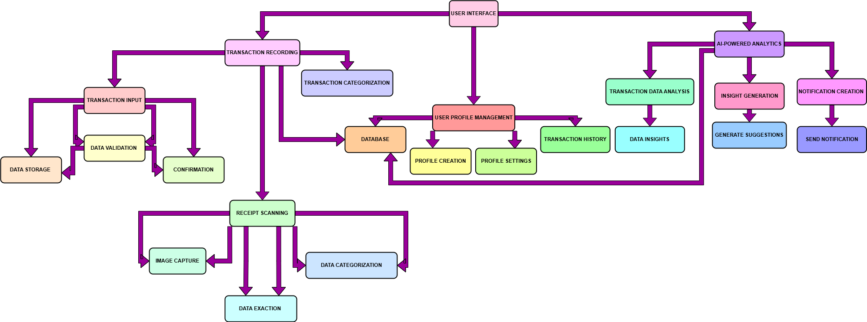

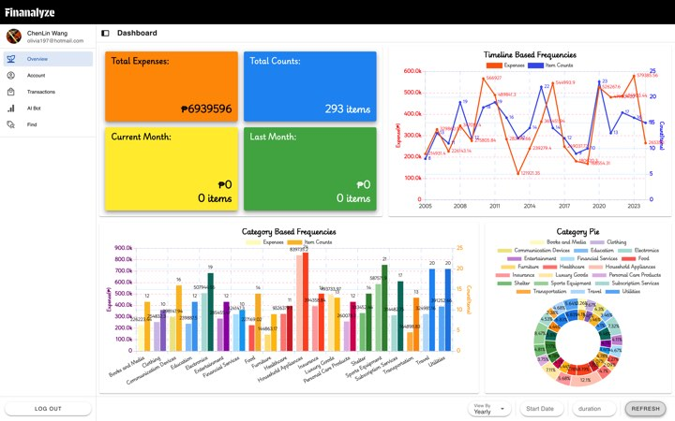
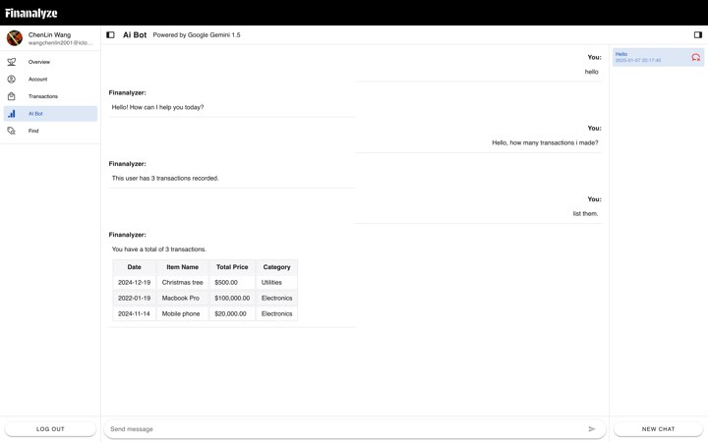
SCREEN LAYOUT

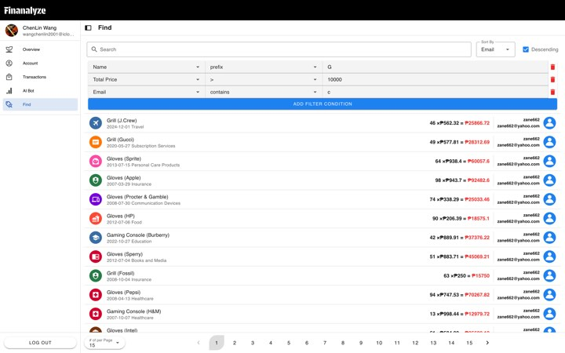

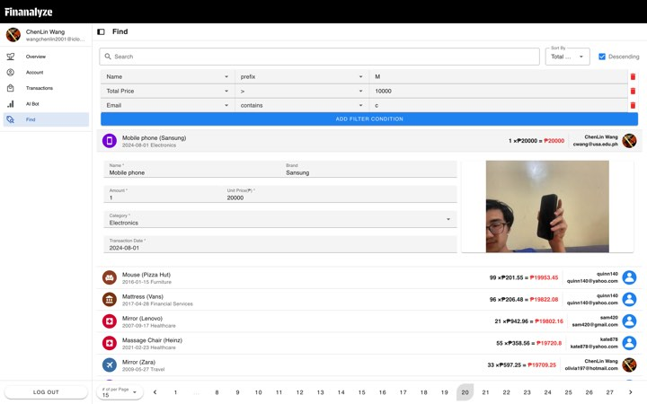

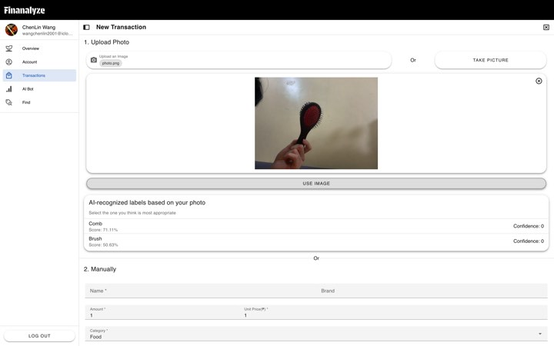

Login Page

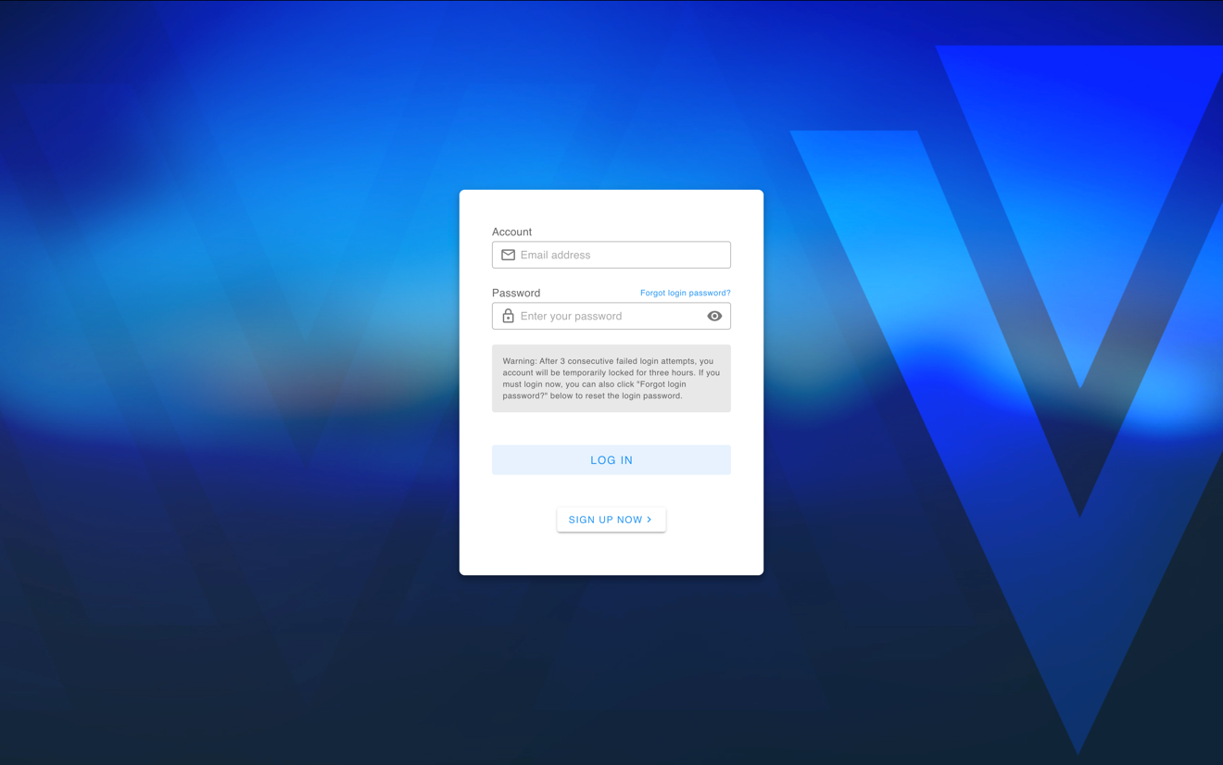

Register Page

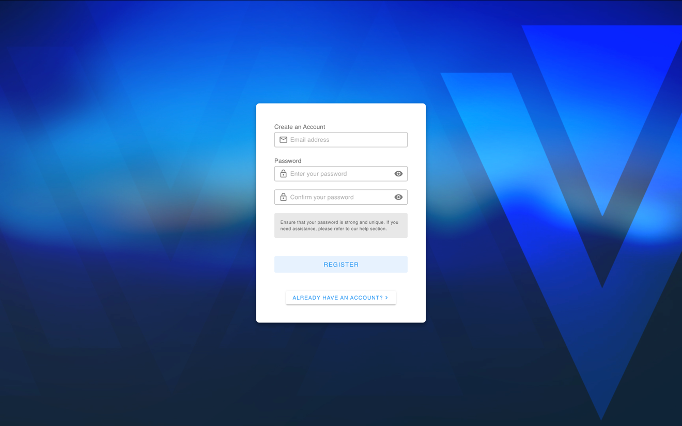

Home Page

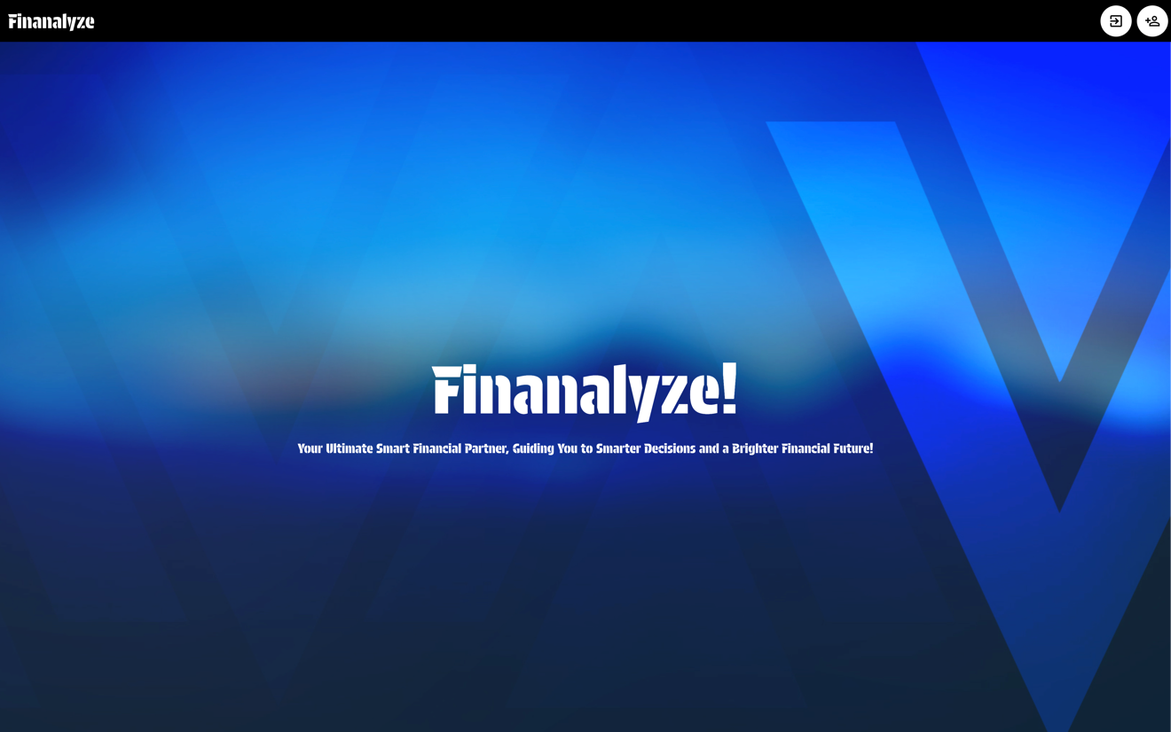

SECTION 4

PROJECT MANAGEMENT

In this section, the focus will be on outlining the key aspects of project management for the proposed system. It will detail the planning, scheduling, and resource allocation needed to successfully execute the project. This section will also highlight the roles and responsibilities of the team members, the timeline for implementation, risk management strategies, and the overall approach to managing the project from initiation to completion.

SOFTWARE RECOMMENDATION

To run the system efficiently, it is recommended to use modern operating systems like Windows 10/11, macOS, or a Linux distribution (Ubuntu or CentOS), as these provide the necessary environment for the software to function without compatibility issues. A relational database management system (DBMS) such as MySQL or PostgreSQL is essential to manage the system’s data securely and effectively. For software development and troubleshooting, integrated development environments (IDEs) like Visual Studio Code, IntelliJ IDEA, or PyCharm should be used, as they offer debugging, version control, and package management tools. If the system includes web-based components, web server software such as Apache or Nginx will be needed to manage HTTP requests and ensure secure communication. Security software like Norton or McAfee, along with SSL certificates and encryption tools like OpenSSL, should be in place to protect the system and data. To ensure data protection, reliable backup software such as Acronis or Veeam should be used for regular data backups and recovery. For creating a user-friendly graphical interface, UI frameworks such as React or Angular (for web-based interfaces) or Flutter (for mobile) are recommended. These software tools together will ensure the system runs smoothly, securely, and efficiently while supporting scalability and a positive user experience.

HARDWARE SPECIFICATION
The minimum hardware specifications required for the installation of the system include a multi-core processor with at least 2.0 GHz speed, such as an Intel Core i5 or equivalent, to ensure efficient performance. The system should have a minimum of 8 GB of RAM for smooth multitasking and handling of the necessary operations. Storage should be at least 500 GB, with a preference for an SSD (Solid State Drive) to improve data access speed and overall system performance. The operating system must be compatible, with options including Windows 10/11, macOS, or a suitable Linux distribution that supports the required software and development tools. A monitor with a resolution of at least 1280x720 pixels (HD) will be required for clear display of system interfaces, and a stable internet connection is essential for software updates, cloud-based features, and communication with external databases or services. Peripherals such as a keyboard, mouse, and optional printer or barcode scanner may also be needed depending on the specific use case of the system. These hardware specifications will ensure that the system runs efficiently and meets the performance needs of its users.

PEOPLE WARE SPECIFICATION
The primary users of the system will be consumers who use the Finanalyze tool to track their expenses, analyze spending patterns, and manage transaction records. These users should have basic computer literacy, as the system is designed to be intuitive and user-friendly, with simple navigation and clear instructions. For training, end-users will need guidance on how to input transaction details, use the receipt scanning feature, and understand the AI-generated insights. Additionally, there will be different access levels in the organization: consumers (end-users) will have access to their own transaction records, profiles, and analytics; system administrators will manage user accounts, monitor system performance, and ensure security; and data analysts will focus on interpreting the system's AI-driven analytics and generating reports to provide valuable insights for the users. Administrators will require training on system maintenance and troubleshooting, while data analysts will be trained on interpreting the analytics data to provide guidance to users on their financial habits.

SYSTEM’S BUDGET
- Development Cost:
  - Frontend (Nuxt.js + Vue.js + TypeScript): PHP 112,000
  - Backend (Vapor + Swift): PHP 112,000
  - Database setup (PostgreSQL): PHP 112,000
- AI Integration:
  - Google Vision AI (Receipt Analysis): PHP 112,000
  - Google Gemini 1.5 (Chatbot): PHP 112,000
- Hosting and Deployment:
  - Google VPS (Ubuntu 22.04.5 LTS): PHP 134,400 annually
- Miscellaneous Costs:
  - Team management tools, licenses, etc.: PHP 89,600
Total Budget:
- PHP 784,000 (Development + 1st-year operating costs

COST-BENEFIT ANALYSIS
Cost-Benefit Analysis
- Monetary Savings:
  - Estimated annual savings for an average user: PHP 2,800
  - With a user base of 1,000 in the first year, projected benefits: PHP 2,800,000
- Projected ROI:
  - ROI = (PHP 5,600,000 - PHP 784,000) / PHP 784,000 ≈ 257.14%
Comparatively, a bank deposit offering ~4% annual return would result in significantly lower returns than Finanalyze's projected ROI.

TIME MANAGEMENT

Activity Code | Description/Task | Duration | Dependencies | Progress
1 | Data Gathering | 31 days (Sep 16 – Oct 17) | None | Completed
2 | Functional Design & References | 3 days (Sep 16 – Sep 19) | None | Completed (Sep 19)
3 | UI Design | 7 days (Sep 19 – Sep 26) | Task 2 | Completed (Sep 29)
4 | Coding/Implementation | 21 days (Sep 26 – Oct 17) | Tasks 2, 3 | Completed (Oct 21)
5 | Testing & Debugging | 3 days (Oct 17 – Oct 20) | Tasks 2, 3, 4 | Completed (Oct 21)
6 | Finalization of Project Plan | 11 days (Oct 20 – Oct 31) | Tasks 1–5 | Completed (Dec 31)

Project Completed on Time: December 3, 2024.

BIBLIOGRAPHY

Bishop, C. M. (2006). Pattern Recognition and Machine Learning. Springer.

This book provides a comprehensive introduction to machine learning techniques, including topics that could support the AI-powered analytics in Finanalyze.
Goodfellow, I., Bengio, Y., & Courville, A. (2016). Deep Learning. MIT Press.

This resource is crucial for understanding the fundamentals of deep learning algorithms that could be applied to Finanalyze’s AI-based features like receipt scanning.
Brock, J. A., & Lacy, J. (2018). Nuxt.js Essentials: Building Server-Side Rendered Apps with Vue.js. Packt Publishing.

A practical guide to using Nuxt.js and Vue.js for frontend development, which is the technology stack recommended for Finanalyze's user interface.
Evans, E. (2012). Domain-Driven Design: Tackling Complexity in the Heart of Software. Addison-Wesley.

This book provides valuable insights on designing complex systems, useful for structuring the Finanalyze system’s backend.
Finkelstein, A., & Asprou, M. (2020). Machine Learning for Business Applications: Predictive Analytics and Decision-Making with Python. Wiley.

This book offers a comprehensive understanding of how machine learning models can be applied to solve real-world business problems, which would be relevant for Finanalyze's AI-powered analytics.
IBM Corp. (2021). IBM Watson: AI-Powered Financial Services. Retrieved from https://www.ibm.com/watson-financial-services

An example of AI-powered analytics in financial services, useful for understanding the application of AI in Finanalyze.
Lee, K., & Lee, J. (2021). PostgreSQL: Up and Running: A Practical Guide to the Open Source Relational Database. O'Reilly Media.

A guide to setting up and managing PostgreSQL, which is the database recommended for Finanalyze.
Baker, S. (2019). Modern Web Development with Vue.js. Manning Publications.

This book covers the latest trends and techniques in frontend web development using Vue.js, a core technology for Finanalyze’s frontend development.
Google Cloud (2020). Google Cloud Vision AI Documentation. Retrieved from https://cloud.google.com/vision

Google Vision AI can be leveraged for Finanalyze’s receipt scanning feature. This official documentation provides insights into how it works and how to integrate it.
Koch, C. (2021). PostgreSQL Performance Tuning. O'Reilly Media.

A resource for optimizing database performance in PostgreSQL, important for ensuring the efficiency of Finanalyze’s backend.

APPENDIX PAGE

Based on your document, the Appendix can include supplementary materials such as the project timeline, survey questionnaire, results, and graphs. Below is a draft of how the appendix might look:

APPENDIX

Appendix A: Project Timeline
Activity Code | Description/Task | Duration | Dependencies | Progress
1 | Data Gathering | 31 days (Sep 16 – Oct 17) | None | Completed
2 | Functional Design & References | 3 days (Sep 16 – Sep 19) | None | Completed (Sep 19)
3 | UI Design | 7 days (Sep 19 – Sep 26) | Task 2 | Completed (Sep 29)
4 | Coding/Implementation | 21 days (Sep 26 – Oct 17) | Tasks 2, 3 | Completed (Oct 21)
5 | Testing & Debugging | 3 days (Oct 17 – Oct 20) | Tasks 2, 3, 4 | Completed (Oct 21)
6 | Finalization of Project Plan | 11 days (Oct 20 – Oct 31) | Tasks 1–5 | Completed (Dec 31)
Note: The project was completed on time, on December 3, 2024.

Appendix B: Survey Questionnaire and Results
Survey Questions:
- How often do you track your daily expenses?
  - Daily
  - Weekly
  - Monthly
  - Rarely/Never
- What challenges do you face in managing your finances?
  - Lack of tools
  - Lack of time
  - Forgetfulness
  - Other: ____________________
- Would you be interested in using an AI-powered financial tracking tool like Finanalyze?
  - Yes
  - No
  - Maybe
Results Summary:
- 75% of respondents track expenses weekly.
- 65% reported forgetfulness as their main challenge.
- 80% expressed interest in an AI-powered tool.

Appendix C: Graphs from Survey Responses
Graph 1: Frequency of Expense Tracking
(Include a bar graph showing percentages for daily, weekly, monthly, rarely/never responses.)
Graph 2: Challenges in Financial Management
(Include a pie chart showing proportions of challenges like lack of tools, time, forgetfulness, etc.)
Graph 3: Interest in Finanalyze
(Include a bar graph showing the percentage distribution of responses: Yes, No, Maybe.)

